APR Workshop Schedule FALL 2019
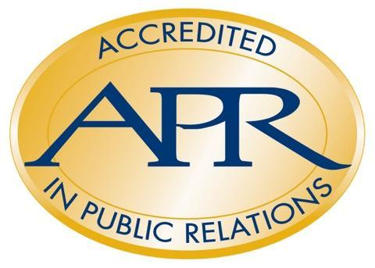
Mondays, 6 p.m. – 7:30 p.m.

Sept. 16, Webinar Use access code: 808 762 814 Trouble accessing? Text: 407-257-4781

Sept. 23 – Oct. 21,
University of Central Florida Downtown Campus
Communication and Media Building, Conference Room 201
500 West Livingston Street, Orlando, FL 32801

Textbook: Cutlip & Center's Effective Public Relations, 11th Ed
Study Guide: www.praccreditation.org/resources/documents/ apr-study-guide.pdf (4th Edition)
DATE | TOPIC | STUDY GUIDE | Effective PR CHAPTER HIGHLIGHTS | % OF EXAM
Sept. 16  Webinar | KICK-OFF  Intro to Accreditation  Application Process  FAQs for 2018 Exam  Written Submission  Portfolio Preparation  Panel Presentation | APR Study Guide, pp 5-9, 14; 127-146 | Chapters 1, 2
Sept. 23 | RPIE:  Research  Planning,  Implementation,  Evaluation | pp. 28-43  pp. 20-59 | Chapter 11  Chapters  12-14 | 33% for all of RPIE
Sept. 30 - Deadline to Submit ELIGIBILITY FORM/APPLICATION to UAB – 5 PM
Sept. 30 | Communication Models, Theories and History;  Ethics & Law | pp. 111-127  pp. 100-107 | Chapters 1,  4, 7, 8 & 12;  5 & 6 | 8%  13%
Oct. 7 | Managing Issues and Crisis Communications | pp. 107-111 | Chapters 1, 11-13 | 13%
Oct. 7 – Deadline for WRITTEN SUBMISSIONS – 5 PM
Oct. 14 | Managing Relationships  (Includes Media Relations, internal com., electronic com.) | pp. 86-96 | Chapters 4, 6, 7, 9, 10, 12 & 16 | 15%
Oct. 21 | Leading the PR Function (Includes: Business Literacy, Mgt Skills, Org structure, Leadership Skills, Problem Solving) | pp. 63-81 | Chapters 2, 3, 4, 9, 11, 15-19 | 18%
Oct. 28 – MOCK PANEL PRESENTATIONS
Nov. 11-15 – PANEL PRESENTATIONS

APR Chairs / Coaches
PRSA  Laura Lord-Blackwell, APR  407-257-4781  Laura.Lord@ocfl.net | FPRA  Tommiea Jackson, APR  662-609-0169  Tommiea.Jackson@ucf.edu
Mimi Flatley, APR
407-885-1405
mflatley@tcco.com

